**Interdisciplinary Curriculum Map**

NAME:

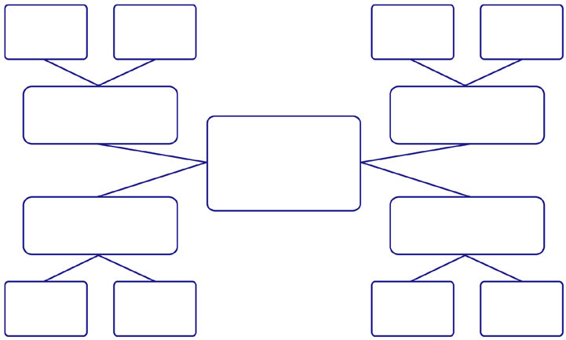

Quiz/Test Score

Calculation

Venn Diagram

Math

Drawing a Composition based on a Poem

Using Symbolic Imagery

Art

The Romantic

Era

Famous Poets

Biography

History/Social Studies

Creative

Writing

Poetry

English Language Arts

The Romantics Thematic Unit